Please read **p 40 to p 48** (keep referring to those pages because they tell you exactly what to do). Adhere strictly to the relationships in the diagrams. I’ve highlighted the most important things that have to be implemented by tomorrow night. It won’t be a lot of work for the individual. Hanrich, please assign people to different categories. (…) indicates how many people I think should work on that group of functionality. While implementing, pay attention to the exact **definition** of **objects** as per the specs, so that you know how to extract the information you need. It might feel silly to code something that refers to things that have not yet been implemented, but we have to start somewhere. **Please coordinate who designs which classes, they are all in the spec.**

**Allocations:**

**status (1 person – You also design the classes in the buzzSpace module on page 43)**

setStatusCalculator

*updateStatusPoints*

* updateAllStatusPoints
* updateStatusPointsForProfile

getStatusForProfile

**profileAssessment(2 people – Also design the classes in the profileAssessment package on page 42)**

**Lana**

assessProfile

registerProfileAssessor

**appraisals (2 people – Also design classes on page 45)**

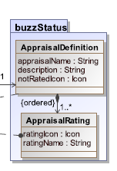**Please note: I think the figure on page 42 should actually be like the one on the right here (not too sure)**

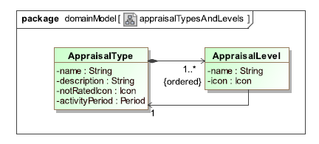

**🡪**

assignAppraisalToPost

getAppraisalsForPost

*manageAppraisalTypes*

* removeAppraisalType
* createAppraisalType
* activateAppraisalType